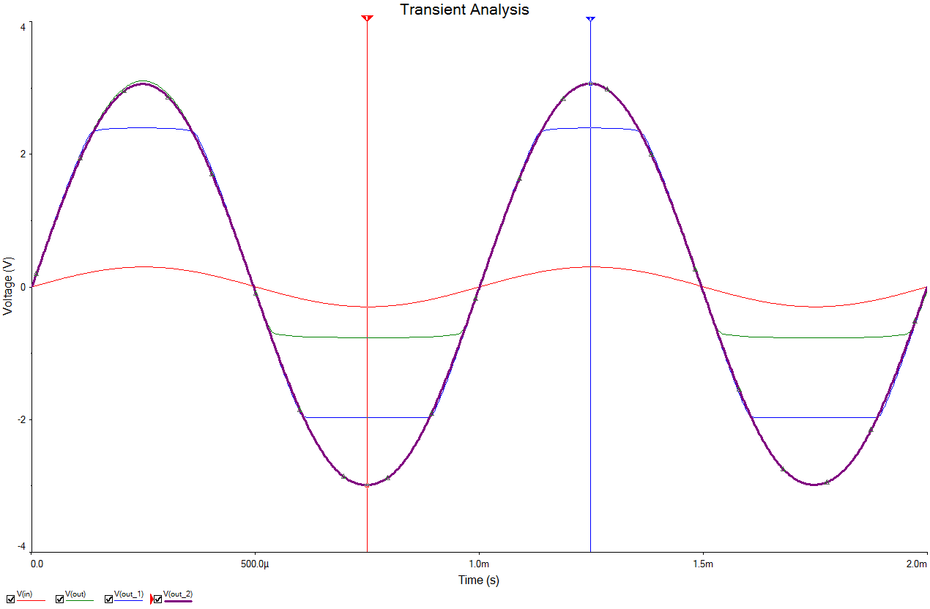

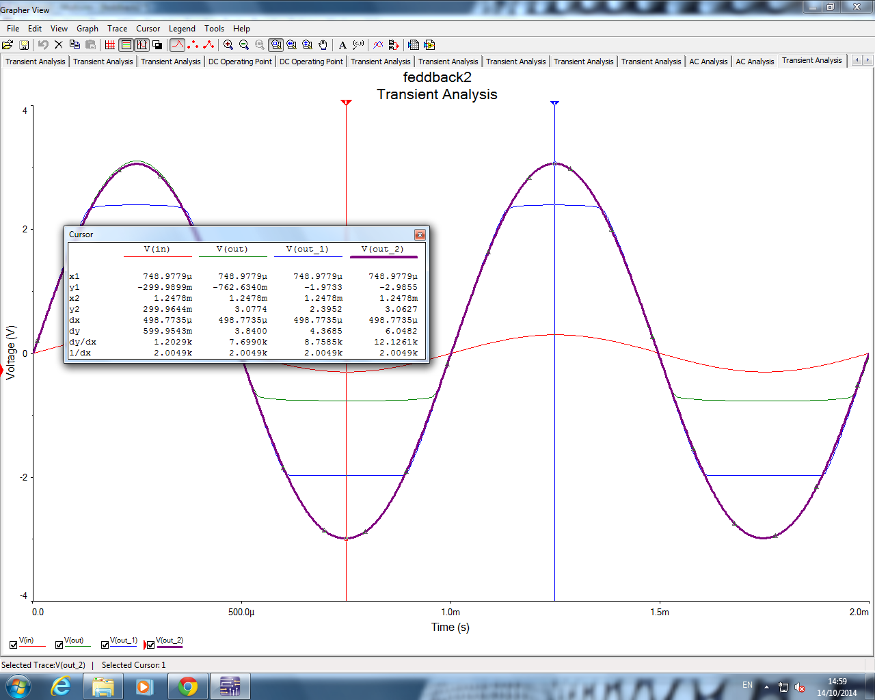

<http://hyperphysics.phy-astr.gsu.edu/hbase/electronic/feedn.html>

<http://www2.engr.arizona.edu/~brew/ece304spr07/Pdf/VBE%20Design.pdf>